# Sri Dharmasthala Manjunatheshwara

**Polytechnic, Ujire - 574240**

**Department of Technical Education FORMAT - 1**

**Student Internship Application**

(Complete and submit to the Training and Placement Officer)

|  |  |  |  |  |
| --- | --- | --- | --- | --- |
| Student Name | | YASHWANTH GOWDA MK | | |
| Register No | | 497CS22063 | | |
| Email address | | [mkyashwanthgowda@gmail.com](mailto:mkyashwanthgowda@gmail.com) | | |
| Name of the institute | | S D M Polytechnic Ujire | | |
| Name of the Programme | | Computer Science and Engg | | |
| Specialisation Pathway | | Full Stack Development | | |
| Pathway code | | 20CS52I | | |
| Overall CGPA | |  | | |
| Internship  preferences | Location | | Core area | Organisation |
| Preference 1 |  | |  |  |
| Preference 2 |  | |  |  |
| Preference 3 |  | |  |  |
| Signature of Cohort Owner Date: | | | | |
| Signature of the Student Date: | | | | |

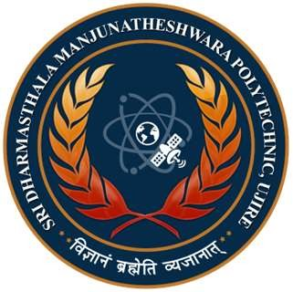

To,

# Sri Dharmasthala Manjunatheshwara Polytechnic, Ujire - 574240

**Department of Technical Education FORMAT - 2**

**Student Internship Application**

(To be forwarded by the Training and Placement Officer/Student)

Date:

Vikram Naresh

CEO at 1990Minds - Web Development Company 1st Floor, No.34 Muleva Blavau Manganahalli Cross, Ullal Main Rd, opp Sri Chaitanya PU College, Bengaluru, Karnataka 560056

Subject: Request for 16 weeks Semester long internship training of Diploma in Computer Science and Engg

Dear Sir/ Madam,

This is to certify your good office to allow Mr/ Ms UMESH KN student of our polytechnic pursuing sixth semester diploma in Computer Science and Engg and trained in Full Stack Development [20CS52I] specialization pathway in boot camp mode to render on-the-job internship training in your prestigious company.

As per the requirement of Diploma in Computer Science and engineering program, he/she is required to complete six hundred and forty (640) hours of internship related to his/her specialization Your support in this regard is highly appreciated.

With warm regards,

Signature of Training and Placement Officer